

EE464

STATIC POWER CONVERSION II

SOFTWARE PROJECT 2 REPORT

Prepared by:

Mehmet Eralp KÖSE 2031094

Muhammet Emin CİNALİOĞLU 2030427

Celal KAVLAK 2030955

Due: 20.04.2018

Table of Contents

INTRODUCTION 3

Q1) 3

a) 3

b) 6

c) 8

d) 9

e) 11

f) 13

Q2) 14

a) 14

b) 20

c) 22

d) 24

i) 24

ii) 24

e) 25

CONCLUSION 25

# INTRODUCTION

In this project we will design a flyback converter. We will start with design a transformer and we will design a controller. In this process we will select core material, switch, diode, capacitor etc. During the transformer design, magnetizing inductance is important to stay in CCM. Also, effects of snubber are observed.

For controlling the output voltage, we need to design a controller which feedback the output voltage to the gate driver of the switch which determines the duty cycle. In design procedure, we should pay attention to keep a stabilized operation of the converter. For this purpose, gain of the error amplifier at switching frequency should be low. Moreover, we should keep phase margin of the controller at least -45 degree.

# Q1)

a)

Let’s assume D=0.4





To find Lm first find the average current flow in Lm





Now let’s assume, current ripple in the magnetization current is equal to 40%.





fs is taken as 100kHz,



Lm is taken as 14.4 , which is explained in part b.

Then, the MATLAB Simulink simulations were done according to values which were found above. 

Figure 1.1: Circuit Schematic of the Flyback Converter

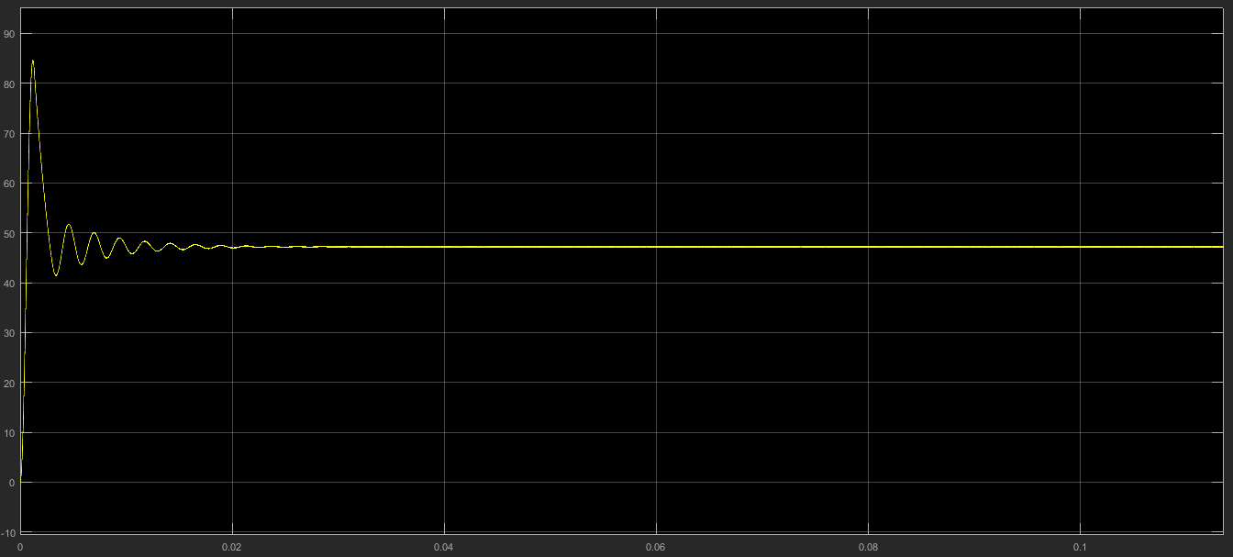

Figure 1.2: Output Characteristic of the Flyback Converter

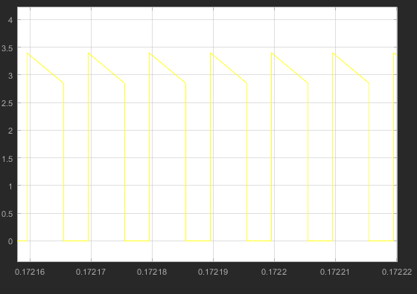

Figure 1.3: Current Flow Characteristic on the Diode

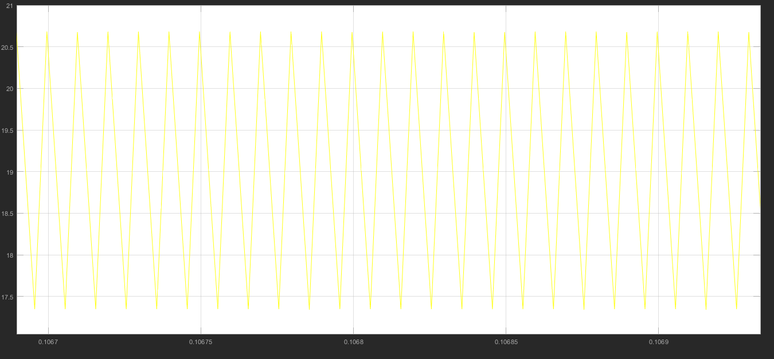

Figure 1.4: Magnetization Current Waveform of the Flyback Converter

## b)

Transformer Design

We use 495-5251-ND as a core. Its material is N41.

Bsat is nearly 0.4T, which does not need excess amount of winding to avoid from saturation. To avoid from saturation, core has enough cross sectional area. Inductance factor of the core is 1.6 µH, which is also proper to reach at least 7.5 µH magnetizing inductance. Operating frequency of the converter is 100 kHz, which is in the optimum frequency range of the core. Core loss at 100 kHz is reasonable.

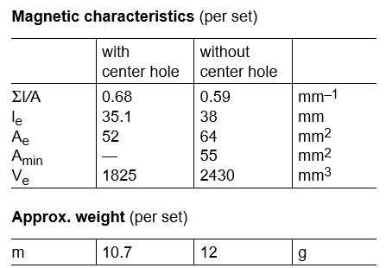

Figure 1.5: Core Properties

(9)

From the equation (9), N1>2

Inductance factor of the core is 1.6 µH. In order to have less ripple than 40% on magnetizing inductance current (from part a), N1 should be 2.17, at least. For N1=3, Lm is equal to

By using the formula (10), N2 is 18.

(10)

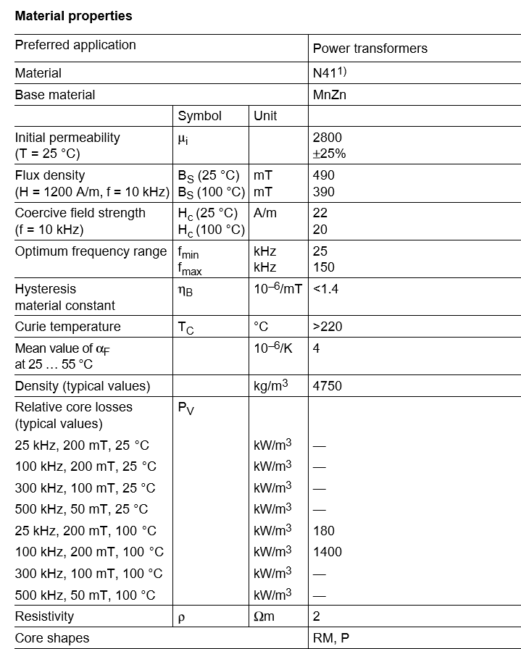

Figure 1.6: Core Material Properties

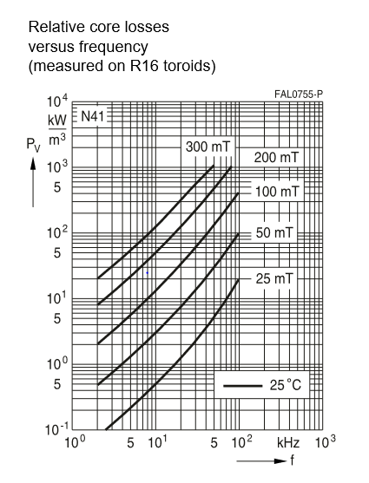

Figure 1.7: Core loss of the material

## c)

Ripple on the magnetizing branch current is 3.5 A. Therefore, at the boundary of CCM and DCM, average inductor current is 1.75 A. Input power is

(11)

Output power is 8.4W if the losses are neglected. Minimum output current is

(12)

## d)

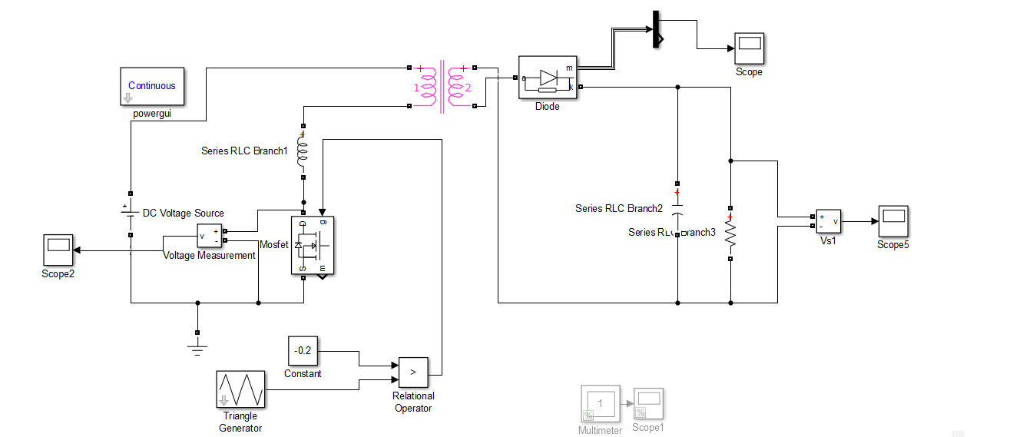

Figure 1.8: Flyback Converter with Leakage Inductance

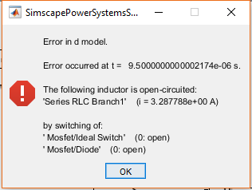

Figure 1.9: Error Caused by Discontinuous Leakage Inductor Current

Leakage inductor current has to be continuous. However, switching causes discontinuity in the current, which results in error inFigure 9. In real, abrupt change in the leakage inductance current cause high voltage difference across the terminals of the switch. Therefore, it is necessary to implement a snubber across the terminals of the primary winding to protect the switch. The snubber will provide a path to current to flow continuously. The snubber seen in Figure 10 helps the switch voltage to stay limited.

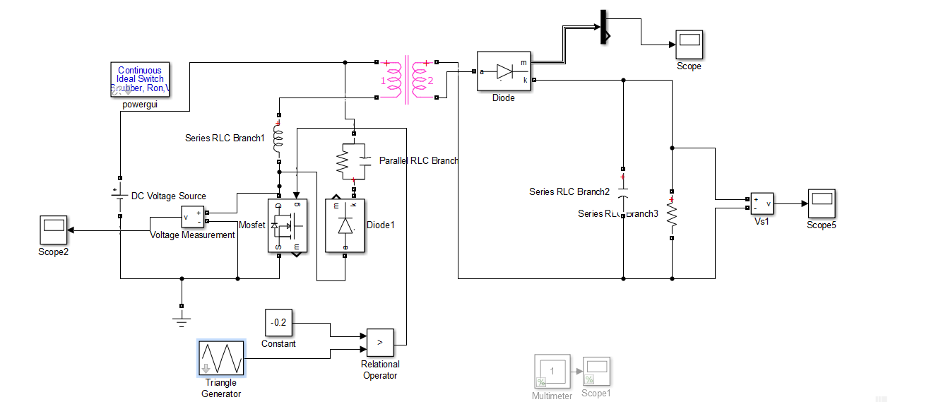

Figure 1.10: Flyback Converter with Leakage Inductance and Snubber

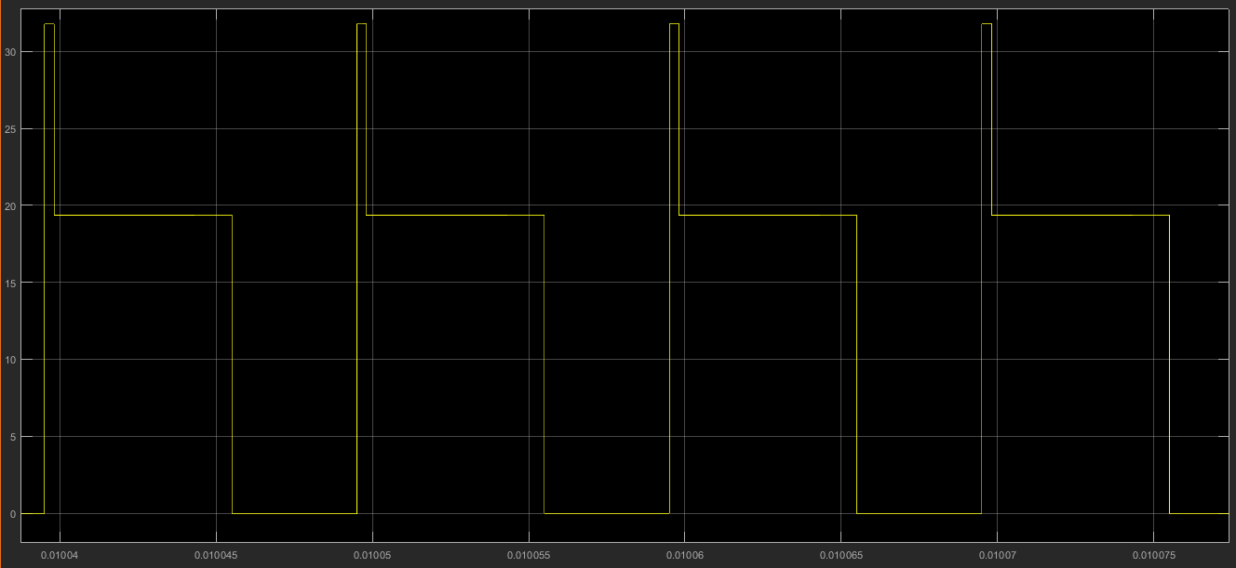

Figure 1.11: Switch Voltage

## e)

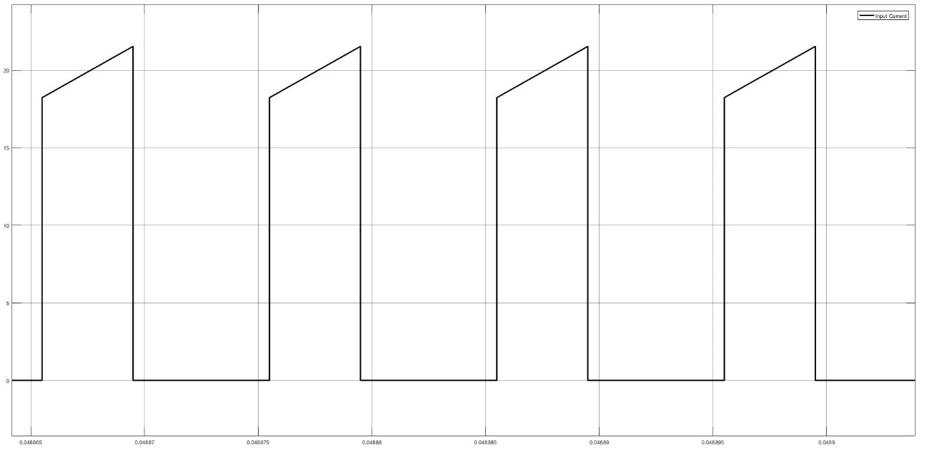

Figure 1.12: Input Current Waveform under Full-Load Operation

Power input during full load operation is,

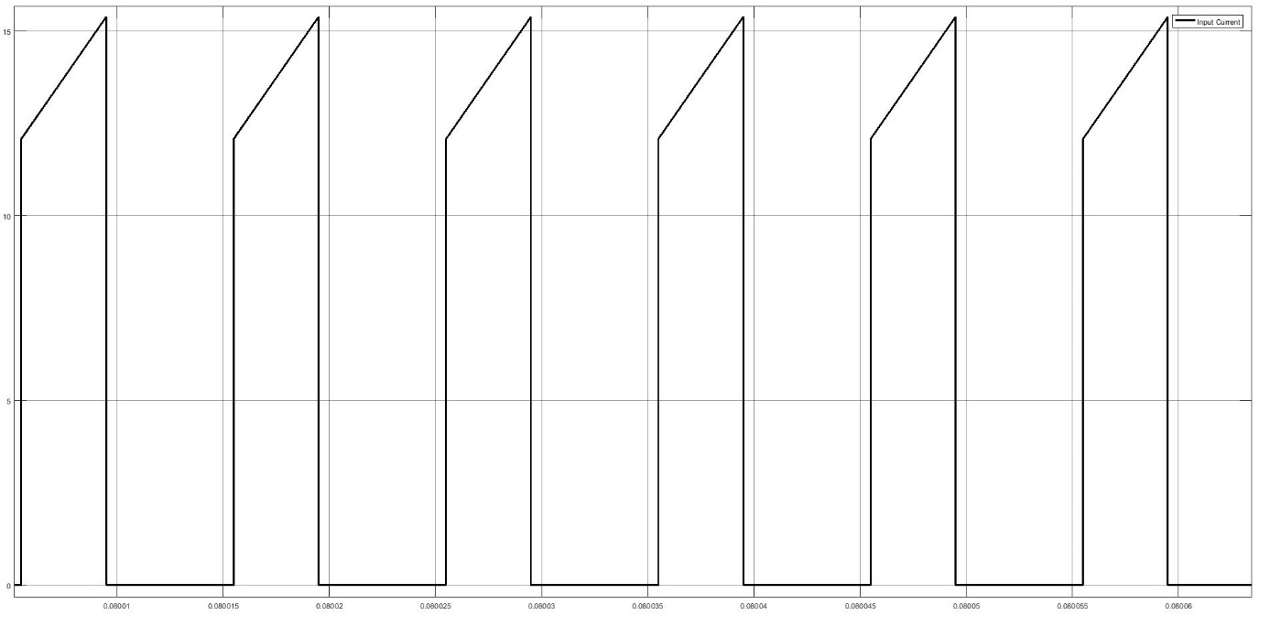

Figure 1.13: Input Current Waveform under 75% Load Operation

Power input during full load operation is,

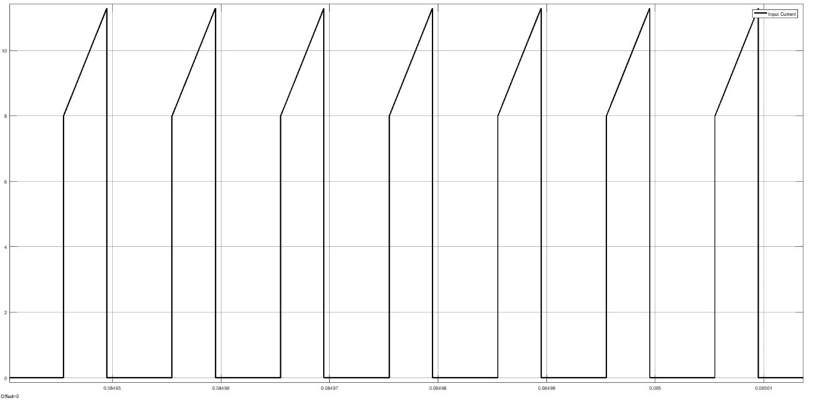

Figure 1.14: Input Current Waveform under 50% Load Operation

Power input during full load operation is,

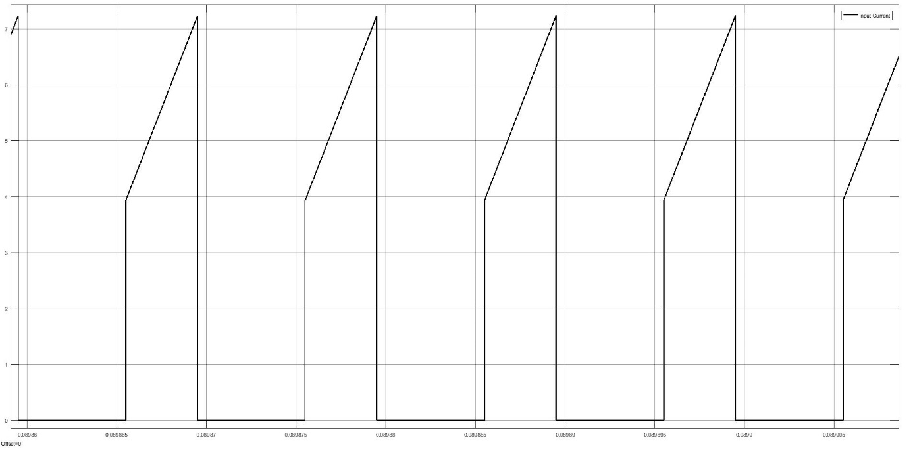

Figure 1.15: Input Current Waveform under 25% Load Operation

Power input during full load operation is,

As expected, efficiency is decreased with decreasing load. Due to transformer used in flyback converter, transformer has low efficiency due to hysteresis losses (magnetization and demagnetization of transformer core) and eddy current at low load. Since at low load, these losses dominate the output power. Then the efficiency of the flyback converter is low under smaller loads. When load further increased efficiency will start to increase until its maximum level. Since also all of the components has finite resistance which caused power losses such as internal resistance of the switch, internal resistance of the capacitance etc.

## f)

Component selection is made by taking cost, performance and compatibility of the products into consideration. Transformer core is selected in part b.

United Chemi-Con EKXG201ELL101ML20S Capacitor is selected for snubber design. Its rated voltage is enough to suppress the voltage caused by leakage inductance current change.

SMC Diode Solutions SB5200TA diode is selected. Its reverse voltage should be at least

(33)

Selected diode’s maximum reverse voltage is 200 V. Diode current is 3.5 A at most drawn by load side, so maximum current of selected diode is 5A. Forward voltage drop is 1.1 V, which is reasonable to use with 48 V output.

IRF540NPBF-ND Mosfet is selected as switch. It has the capability of passing 33 A drain to source current and blocking 100 V drain to source voltage. Drain to source voltage drop of the Mosfet is about 1 V. In designed converter, switch is subject to 21 A drain to source current, 30 V reverse voltage blocking, which is met by selected Mosfet. Reverse recovery time of the Mosfet is 170 ns, which is suitable for 100 kHz switching.

# Q2)

## a)

TRANSFER FUNCTION OF FLYBACK CONVERTER

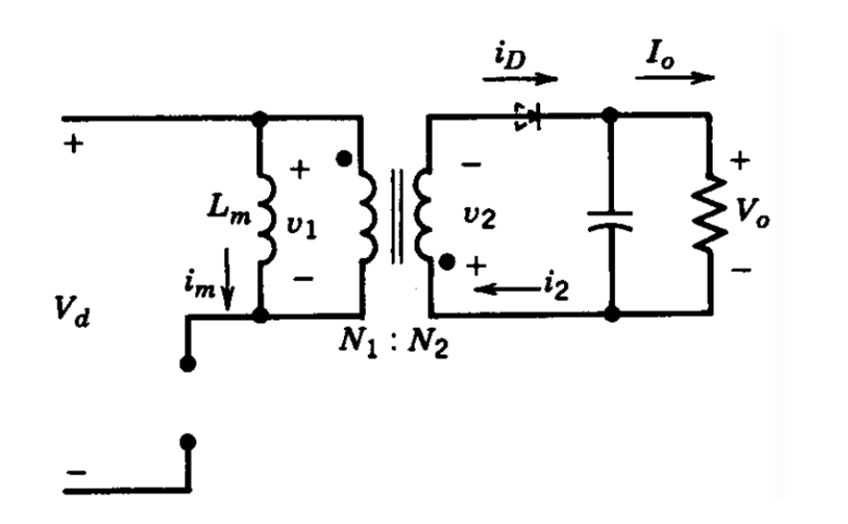

Figure 2.1: Flyback Converter Schematic

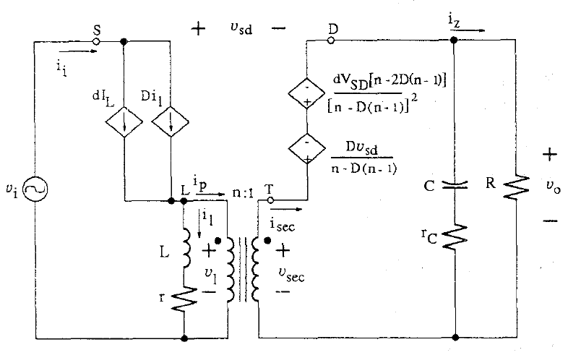

Figure 2.2: Small Signal Model of Flyback Converter

We choose n=1 and circuit schematic will be like that;

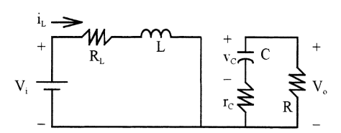

Figure 2.3: Switch ON State When n=1

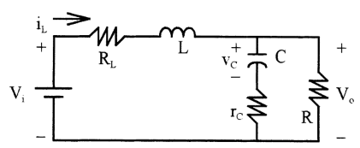

Figure 2.4: Switch OFF State When n=1

By looking ON state:

(34)

(35)

By using Eq. (34) and (35)

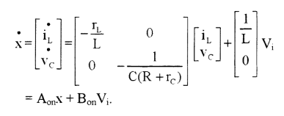

By looking OFF state:

(36)

(37)

By using Eq. (36) and (37)

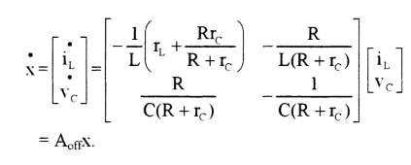

(38)

V0 = [] (39)

A=AON*D+AOFF*(1-D) (40)

B=BON*D+BOFF*(1-D) (41)

C=CON*D+COFF*(1-D) = [ (42)

(43)

By using Eq. (38), (39), (40), (41) and (42),

T(s) is in this form:

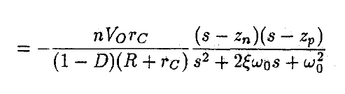 (44)

(n=turn ratio)

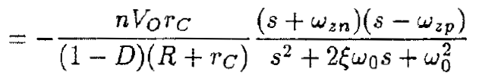

(45)

Where the frequency of negative pole:

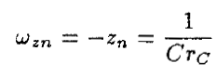 (46)

And the frequency of negative pole:

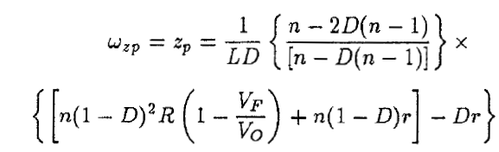 (47)

Angular corner Frequency:

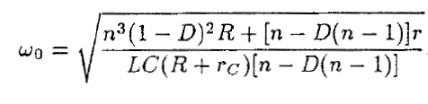 (48)

Damping Ratio:

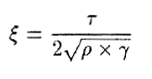 (49)

Where,

 (50)

 (51)

 (52)

In our design,

R=25.6 Ω,

L=14.4 uH,

C=10 uF,

Rc=0.1 Ω

Therefore,

Wzn=105 rad/s,

Wzp=1580138.9 rad/s,

W0=15866 rad/s,

ξ= 0.3119,

Threrefore,

(53)

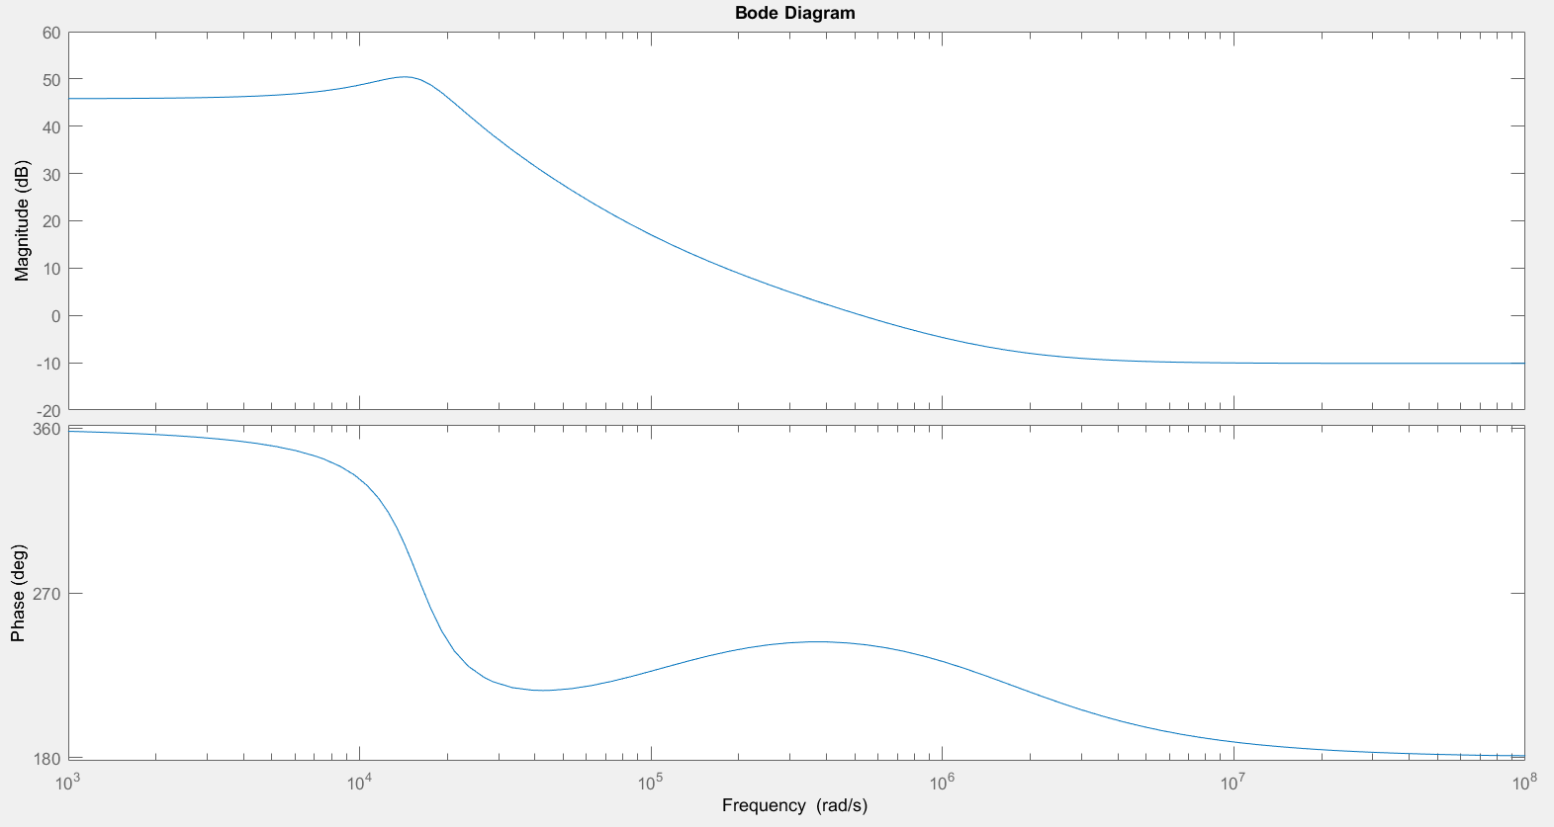

Figure 2.5: Bode Plot for 1:1 Turn Ratio

As shown in Figure 2.5, phase margin is nearly 620 and phase does not drop under -1800. Therefore it is stable system. Also, magnitude and phase waveform characteristics are coherent with flyback converter. At the corner frequency w0, maximum magnitude value is observed as expected. Also, phase margin is coherent with flyback converter. Beyond the frequency wzn of right half plane zero, the grain curve flattens out but the phase angle begins to decrease again. Also, compansator may be necessary in order to increase stability.

We will use 3:18 turn ratio so transfer function is modified for this turn ratio. Now, n=1/6 and

Wzn=105 rad/s,

Wzp=428317.9 rad/s,

W0=2237.84 rad/s,

ξ= 0.677,

(54)

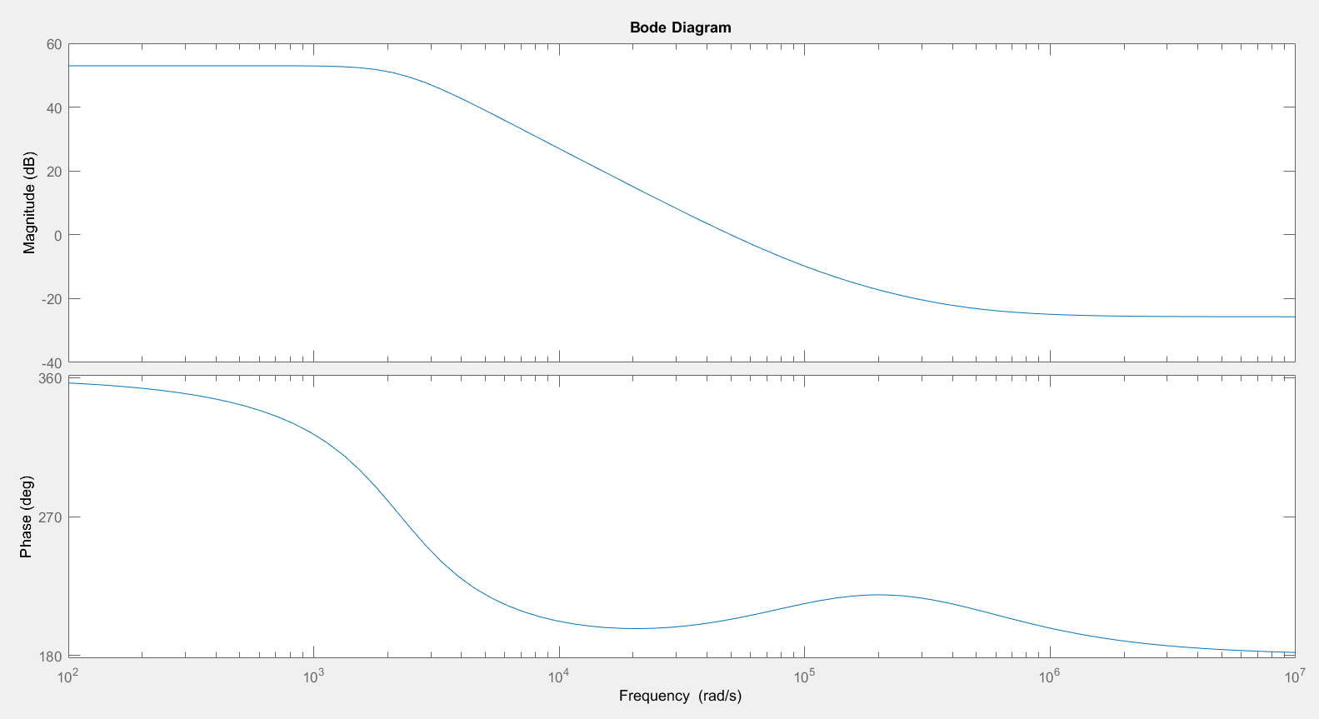

Figure 2.6: Bode Plot for 3:18 Turn Ratio

Again, these magnitude and phase waveform characteristics are coherent with flyback converter topology as explained in flayback converter for 1:1 ratio part. However, phase margin is nearly 250. It is low a bit for stability.

## b)

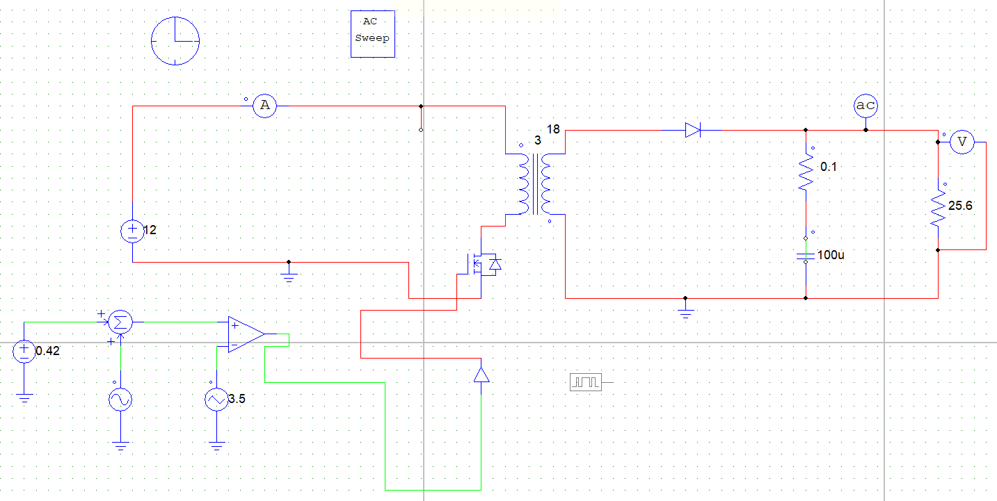

Figure 2.7: Flyback Circuit Schematic

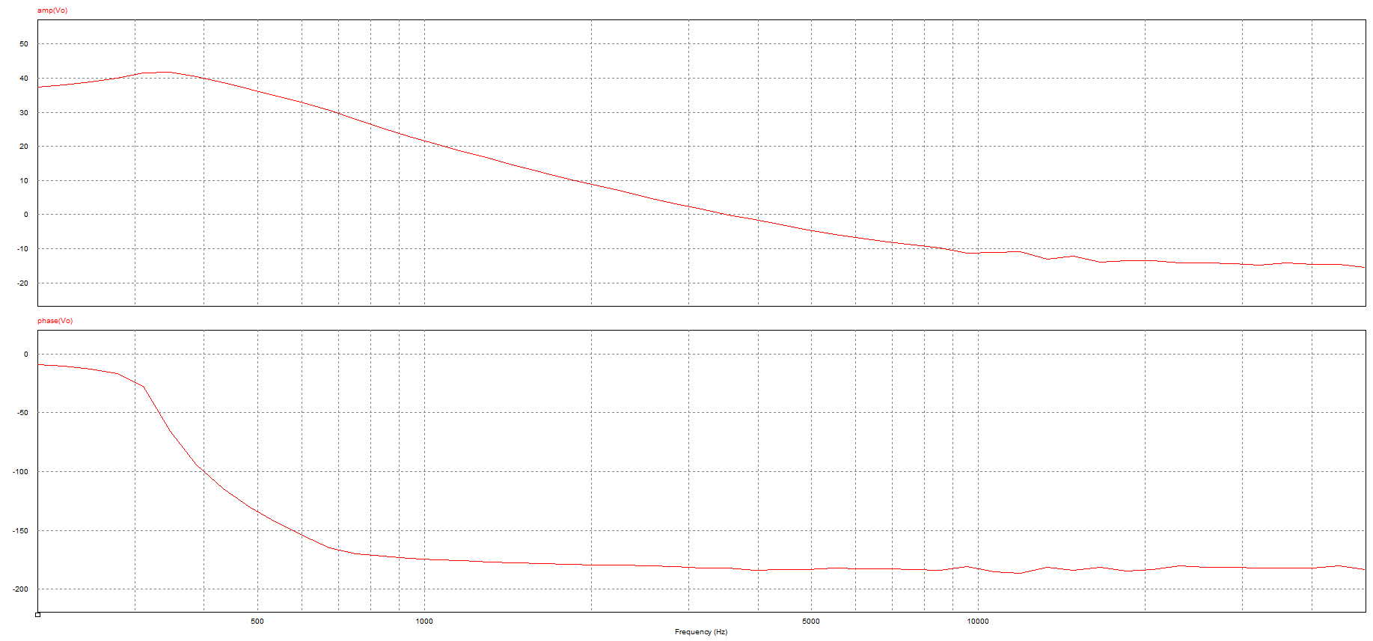

Figure 2.8: Bode Plot for 3:18 Turn Ratio on PSIM

In this part;

R=25.6 Ω,

L=14.4 uH,

C=10 uF,

Rc=0.1 Ω

We simulate flyback converter by using Simulink, Lt Spice and PSIM. 48 V output voltage is observed from 12 V input voltage 48 V; however, there are some problems for bode plot graphs. As shown in Figure 2.8, peak magnitude is observed at angular corner frequency and magnitude and phase waveforms are similar with analytical calculations. However, there is not an increase at wzn frequency.

(Also, frequencies are in terms of rad/sec in MATLAB part in part 2a, whereas frequencies are in terms of Hz in part 2b.)

## c)

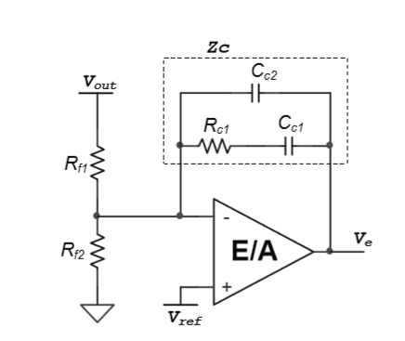

Figure 2.9: Type 2 Controller Model

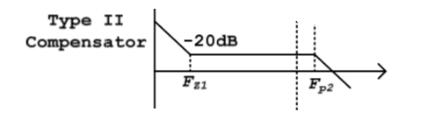

Figure 2.10: Type 2 Compensator Transfer Function Model

In this part, we design type 2 controller. We pay attention that controller pole frequency should be smaller than the switching frequency so low gain is observed at the switching frequency and it makes better the stability.

(55)

(56)

Where,

RC1= 16Ω,

CC1= 10 uF,

CC2= 1 uF,

FZ1 = 1 kHz,

FP2 = 10 kHz

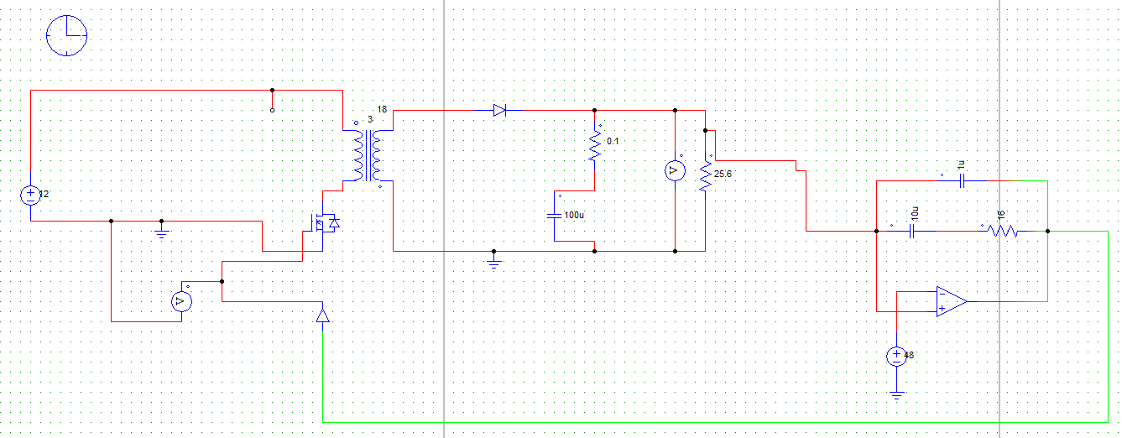

Figure 2.11: Flyback Converter with Type 2 Controller

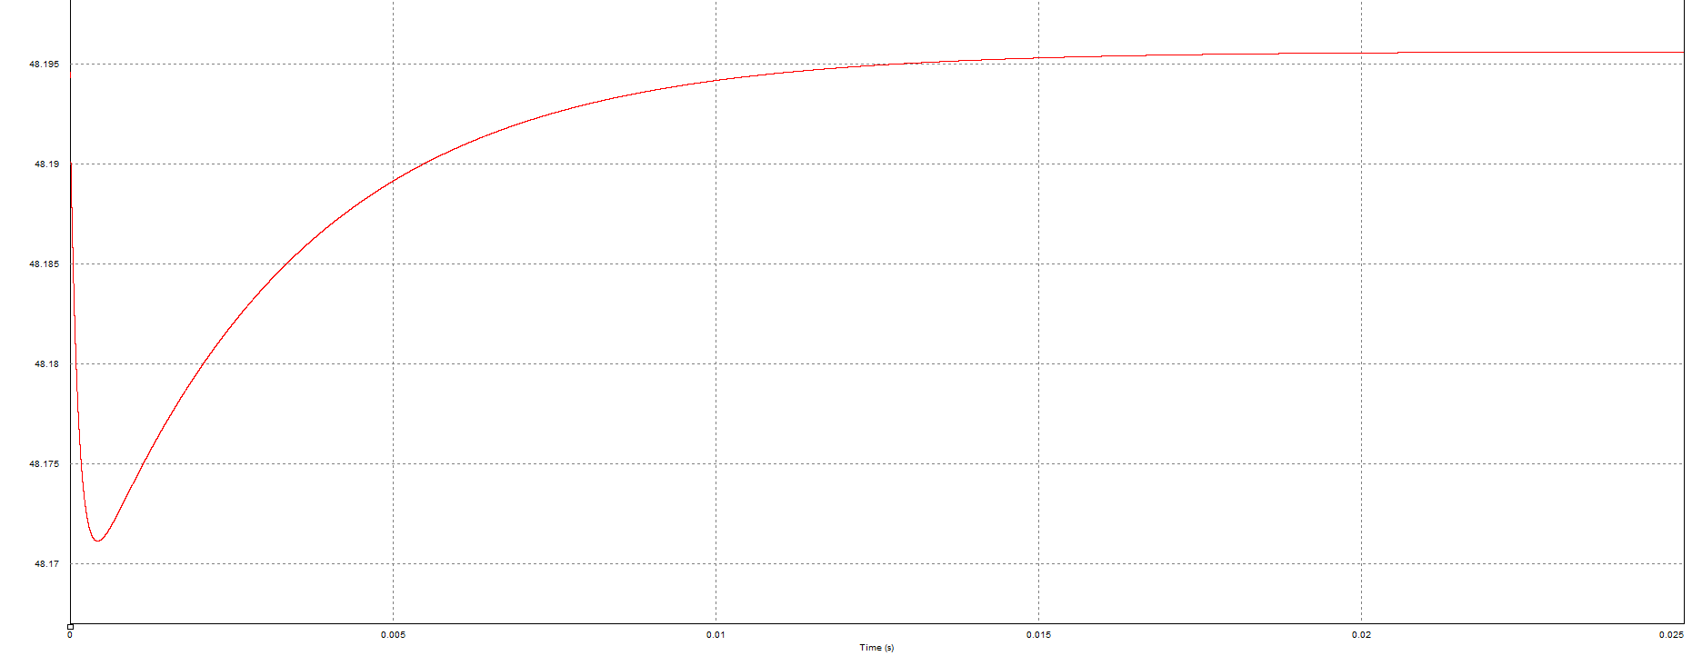

Figure 2.12: Output Voltage for 12 V DC Input

Nearly 48 V output is observed from 12 V input. If input voltage is increased or decreased, 48 V can still be produced.

## d)

### i)

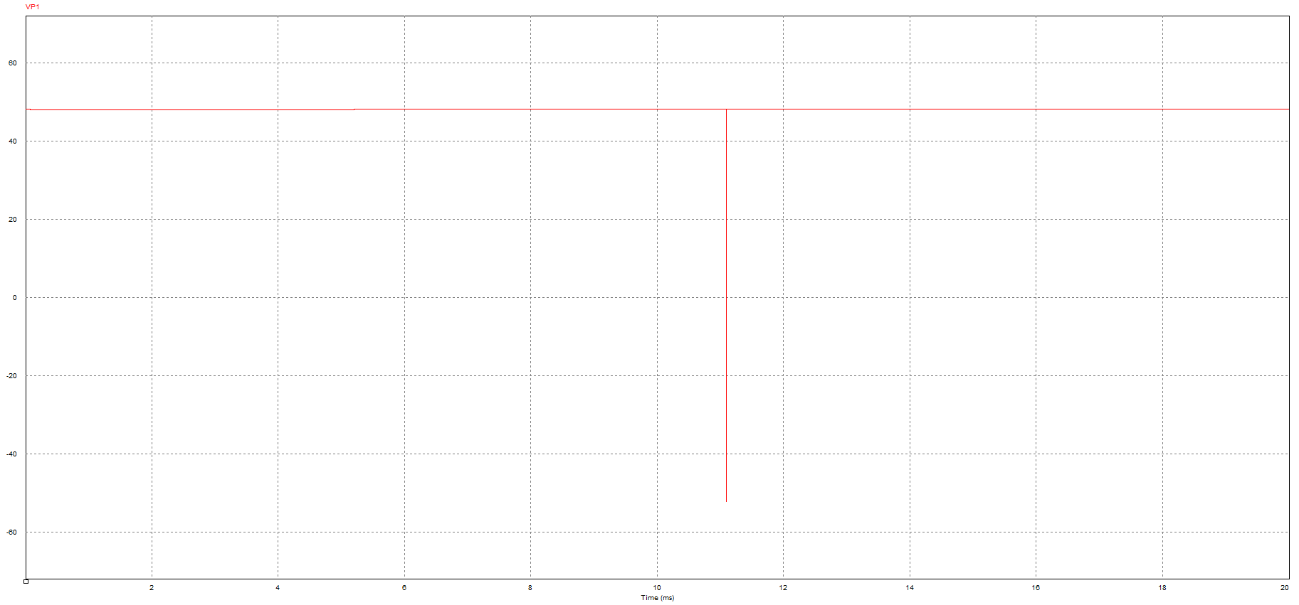

Figure 2.13: Output Voltage when Load from Increase Half to Full

### ii)

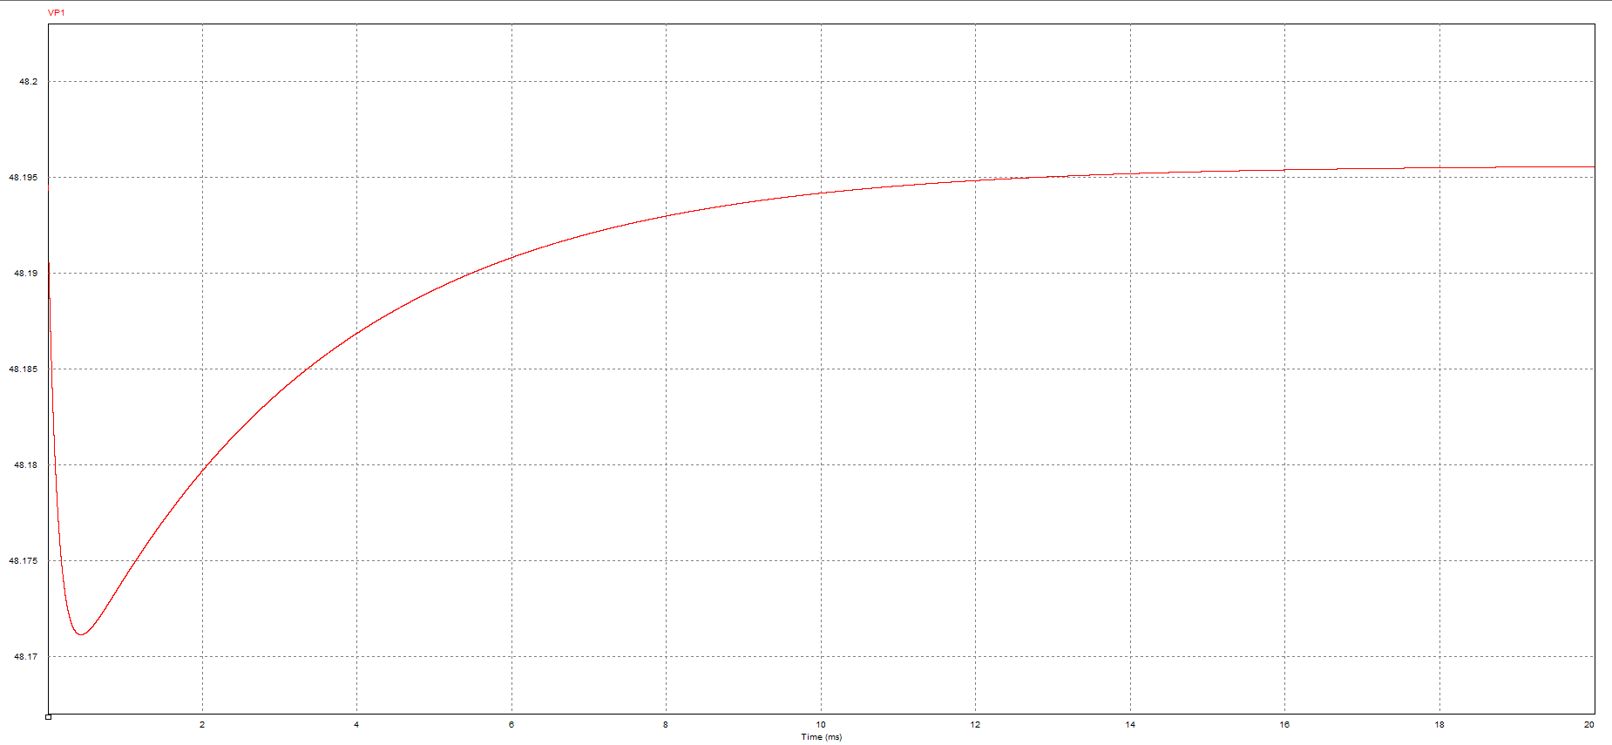

Figure 2.14: Output Voltage when Input Voltage decrease 10%

In this part, the same output characteristics are observed when input or load is changed. It is strange and most probably false. We expected some oscillations and ripples at the instants that load or input is changed; however, we could not observe this transition and we could not solve this problem.

## e)

In this design, we observed that gain at the switching frequency should be low and gain at the low frequency should be high because we want to control DC component and we want to decrease the effect of AC components. We selected pole and zero’s frequencies according to this condition and we selected R and C values of the Type 2 controller in order to achieve these frequencies. If gain was high at high frequency (switching frequency), stability would degenerate.

We should observe a transient period and accuracy should change a bit with respect to load and input voltage but we did not observed this as explained in part d. It may cause that we may miss some ideality etc.

# CONCLUSION

In this project, Flyback design is done. Initially, a core is selected and we design a transformer with real materials. Duty cycle ratio is determined; also, minimum magnetizing inductance is determined in order to stay CCM. Moreover, importance of snubber on the switches is observed and we recognize that snubber is crucial. Also, we choose materials.

On the other hand, controller is another crucial point for a converter. We learned how to find transfer function of a converter and we designed controller. We observed the relation between the controller’s pole and zero frequencies and the switching frequency. These design will help us for our hardware project.